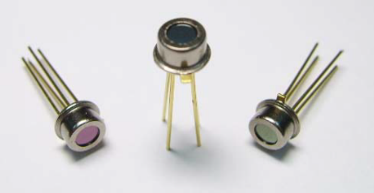
Thermopile Sensor
OTP-538U
Revision Date: 2009/04/16
Introduction
The OTP-538U is a thermopile sensor in classic TO-46 housing. The sensor is composed of 116 elements of thermocouple in series on a floating micro-membrane having an active diameter of 545 μm and with blacken surface to absorb the incident thermal infrared radiation, which induces a voltage response at output terminals. The sensor chip is fabricated by a unique front-surface bulk micromachining technology, which result in smaller size and faster to response ambient temperature change.The IR window is a bandpass filter having its 50% cut-on wavelength at 5 μm, and cut-down at 14μm. The sensor responses proportionally to the incident IR radiation and has a constant signal response up to its cut-off frequency, which is limited by the sensor thermal time constant of tens millisecond range.The OTP-538U thermopile sensor provides nearly Johnson-noise-limited performance, which can
be calculated by its ohmic series resistance. A thermistor element, with a lead connected to ground, is also provided inside the TO package for ambient temperature reference.
Features
􀁺 Non-contact temperature detection
􀁺 Voltage output, easy to take signal
􀁺 Zero power consumption
􀁺 Wide detection temperature range
Applications
􀁺 Medical Application: Ear thermometers
􀁺 Home Facility: Microwave oven, Hair dryer, Safety system, Home security, Refrigerator & Air
conditioner
􀁺 Industry Application: Process monitor and controller, Infrared non-contact thermometers
􀁺 Automobile Application: Thermal sensing system
Table of Contents
1 General Characteristics
1.1 Absolute Maximum Ratings
1.2 Handling Guidelines
2 Device Characteristics
2.1 Device Descriptions
2.2 Sensor Characteristics
2.3 Signal Output Characteristics
2.4 Frequency Response
2.5 Thermistor Characteristics
2.6 Optical Characteristics
2.7 Filter Characteristics
2.8 Mechanic Drawing and Pin Assignment
3 Liability Statement
List of Figures
Figure 1: Typical output voltage versus object temperature with sensor at 25° C
Figure 2: Frequency response
Figure 3: Field of view curve
Figure 4: Typical spectral transmittance curve
Figure 5: Mechanical drawing and pin assignment
List of Tables
Table 1: Absolute maximum ratings
Table 2: Device characteristics
Table 3: Thermopile sensor characteristics
Table 4: Typical numerical data of Thermopile’s output voltage (sensor at 25° C)
Table 5: Thermistor information
Table 6: Tabulated thermistor data
Table 7: Optical characteristics
Table 8: Filter parameters
1. General Characteristics
1.1 Absolute Maximum Rating
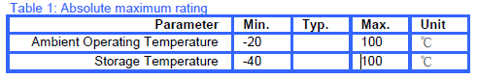
1.2 Handling Guidelines
􀁺 Stresses above the absolute maximum ratings may cause damages to the device.
􀁺 Do not expose the sensor to aggressive detergents such as Freon, Trichloroethylene, etc.
􀁺 Avoid touching or cleaning of the window. If necessary, do cleaning only very carefully with alcohol and
cotton swab.
􀁺 Hand soldering and wave soldering may be applied by a maximum temperature of 260° C for a dwell time
less than 10 s. Reflow soldering is not recommended.
2. Device Characteristics
2.1 Device Descriptions
The materials of OTP-538U are lead-free and fully complied with the RoHS regulations.
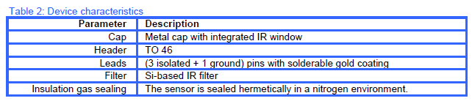
2.2 Sensor Characteristics
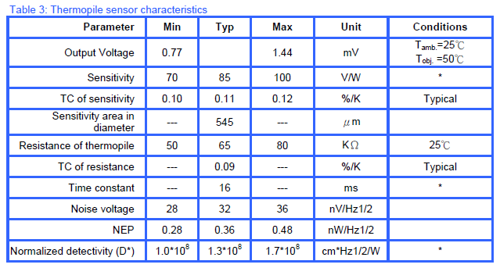
Notes: * All optical performances are measured at 1 Hz chopper frequency using a blackbody
radiator of 500K temperature with filtered spectrum ranging from 5 to 14 μ m.
Distance between packaged thermopile and blackbody is 11cm.
2.3 Signal Output Characteristics
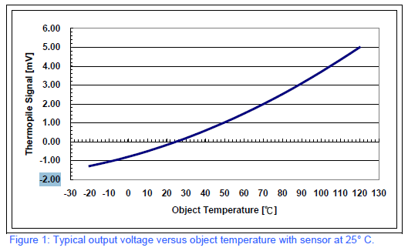
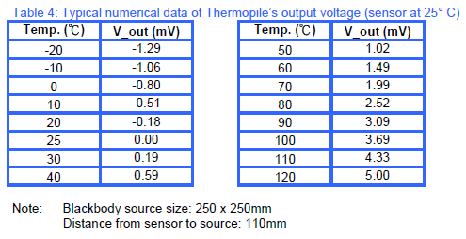
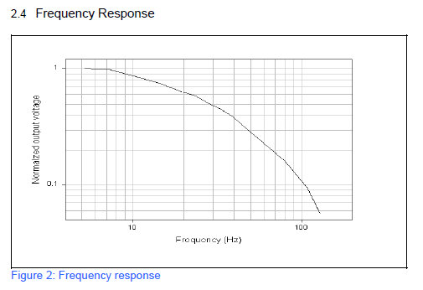
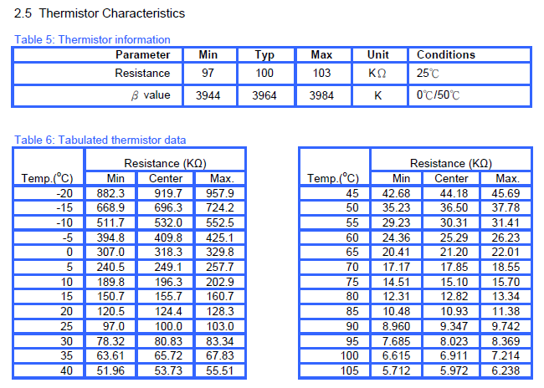
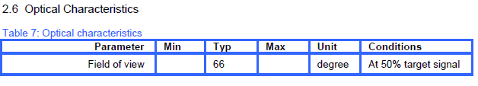
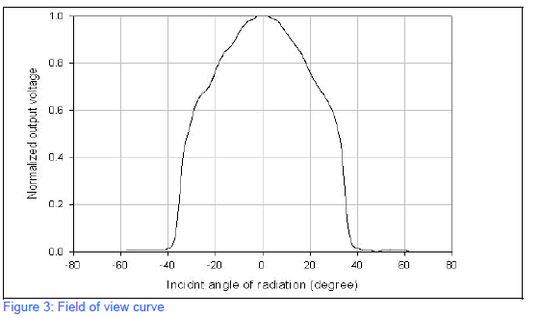
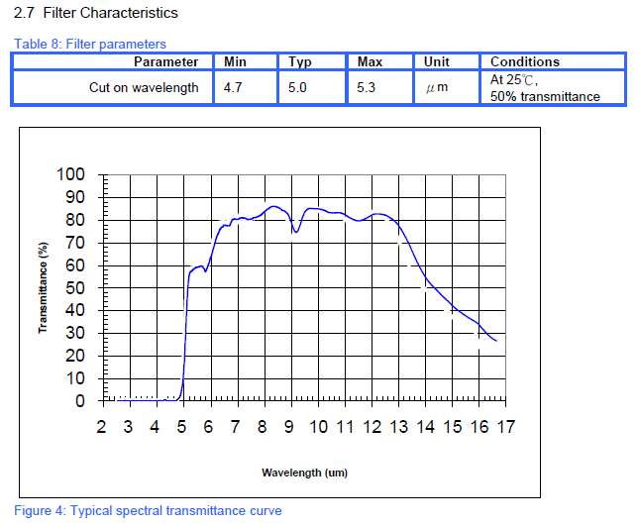
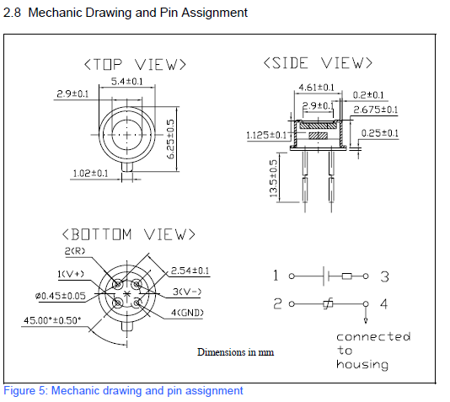
3. Liability Statement
The contents of this document are subject to change without notice and customers should consult with
Oriental System Technology (OST) sales representatives before ordering. Customers considering the use of
OST thermopile devices in applications where failure may cause personal injury or property damage, or where
extremely high levels of reliability are demanded, are requested to discuss their concerns with OST sales
representatives before such use. The Company’s responsibility for damages will be limited to the repair or
replacement of defective product. As with any semiconductor device, thermopile sensors or modules have a
certain inherent rate of failure. To protect against injury, damage or loss from such failures, customers are
advised to incorporate appropriate safety design measures into their product.

